**AI Methods**

**–**

**Cover Sheet**



A S S I G N M E N T

**Instruction:**

* Marks will be awarded for good presentation and thoroughness in your approach.
* Complete this cover sheet and attach it to your assignment.

**Student declaration:**

*I declare that:* ▪ *I understand what is meant by plagiarism*

* + *The implications of plagiarism have been explained by our lecturer*
  + *This assignment is all my work and I have acknowledged any use of the published or unpublished works of other people in documentation.*



|  |  |  |
| --- | --- | --- |
|  |  | **Signature** |
| **Name** | **Terence Lim Dao Liang** |  |
| **TP No** | **TP073243** |  |
| **Name** | **Angelina Leanore** |  |
| **TP No** | **TP072929** |  |
| **Name** | **Ooi Yin Yao** | **** |
| **TP No** | **TP074427** |  |
| **Name** | **Jeff Hong Chee Hin** | IMG_256 |
| **TP No** | **TP074560** |  |
| **Intake** | **APU2F2402CS(AI)/APD2F2402CS(AI)** |  |
| **Research Topic** | **Feature Importance in Neural Network for Hiring Process** |  |

**Feature Importance in Neural Network for Hiring Process**

Terence Lim Dao Liang  
BSc Computer Science in Artificial Intelligence   
Asia Pacific University of Technology & Innovation   
Kuala Lumpur, Malaysia   
[TP073243@mail.apu.edu.my](mailto:TP073243@mail.apu.edu.my)

Angelina Leanore  
BSc Computer Science in Artificial Intelligence   
Asia Pacific University of Technology & Innovation   
Kuala Lumpur, Malaysia   
[TP072929@mail.apu.edu.my](mailto:TP072929@mail.apu.edu.my)

Ooi Yin Yao  
BSc Computer Science in Artificial Intelligence   
Asia Pacific University of Technology & Innovation   
Kuala Lumpur, Malaysia   
[TP074427@mail.apu.edu.my](mailto:TP0734427@mail.apu.edu.my)

Jeff Hong Chee Hin  
BSc Computer Science in Artificial Intelligence   
Asia Pacific University of Technology & Innovation   
Kuala Lumpur, Malaysia   
[TP074560@mail.apu.edu.my](mailto:TP074560@mail.apu.edu.my)

**Abstract**—**This study investigates the interrelation of feature significance and artificial neural networks for recruitment, as there is a growing concern for the assessment of candidates in the job market. This aims to determine the possible candidate’s traits using a neural network in order to determine possible hiring outcomes and to provide insights into factors that affect hiring decisions. The preparation of the model takes data pre-processing training, tuning up, and feature analysis. Permutation Feature Importance (PFI) and SHAP values among others as important in enhancing the accuracy of the model. The conclusions drawn n from this study demonstrate that recruitment decisions are made more accurate through the use of feature importance techniques, which helps, for example, recruiters focus on relevant qualities of the applicants and promotes equity and effectiveness of the recruitment process. In addition, this has useful significance in increasing the efficiency of the hiring processes and enhancing the use of metrics in making recruitment strategies.**

***Index terms: Hiring Process, Neural Networks, Machine Learning, Feature Importance, Data-Driven Decision Making***

# INTRODUCTION

Hiring trends in today’s fiercely competitive job market have shown that it is becoming more and more difficult for candidates to receive employment offers. After the interview round, just one out of five applicants received a job offer, according to Workday’s Global Workforce report. This implies that improving a technique for precisely assessing a candidate’s fitness is crucial. In order to find and prioritize the critical component that has the most influence on candidate’s performance in an interview, this study focuses on using a **Neural Network Model to** forecast the hiring results by evaluating feature significance (Kelly, 2024). To create a binary classification on neural network that separates the most probable candidates from those who might not succeed, this study uses a machine learning framework (Rowe & Johnson, 2020). This approach is intended to identify which characteristics such as experience, skill sets, education level, and other relevant qualities have a significant impact on recruiting choice by utilizing a large dataset of applicant traits (Molnar et al., 1994). This accomplished by the application of feature important methods and the analysis of the accuracy decrease to determine which characteristics are essential for forecasting successful recruiting outcomes.

Data collecting, preprocessing, neural network modelling, training, fine-tuning, and ablation research to increase the prediction capacity of the model are some of the steps required to accomplish this strategy. This study gives us a clear view of how each variable contributes to the hiring forecast and enables us to investigate further the impact of eliminating or changing specific features on model accuracy.

Additionally, this methodology can better prepare candidates for interviews by concentrating on areas of relevance by finding the most influential characteristics. This benefits both the candidate and recruiters by helping them rank the qualities that best indicate a prospect’s likelihood of success (Pessach et al., 2020). With the ability to enhance recruiting choices and raise the success rate of candidates, this strategy fits in nicely with the present need for data impartial hiring. This study provides useful information on candidates with the hiring results, and it also acts as a step toward technologically improving the recruiting process.

# LITERATURE REVIEW

As the interpretation and understanding of machine learning models, especially in terms of their application in an employment context, feature importance procedures are gaining attention. (Ewald et al., 2024) Asser that these procedures are vital for providing an answer to the question of how different variables affect the prediction and ensuring that the inferences made statistically are correct. In the past, the regression approach was predominantly used owing to computational constraint (Mandler et al., 2024), but following the development of artificial neural networks, machine learning models today can efficiently manage a host of interactions and non-linearities (Molnar et al., 2022)

The increase in feature importance techniques has been especially important when it comes to interpretability issues presented by neural networks. Neural networks are regarded as very suitable, but on the other side, the interpretation of neural network’s output is often an issue, because of noise in some irrelevant features that correlate with a target variable (Mandler et al., 2024). To take care of these issues, several measurement methods including permutation importance approaches have been used, where feature values are randomized and shuffles, and the change in the performance of the model being tested is assessed (Abdelaziz et al.,2024)

Recently, studies have shown relevance of these developments in practice relating to recruitment. Modern methodologies have demonstrated great efficiency rates: hybrid models achieve 91% (Khan, 2022) in productivity of recruitment processes, while deep neural networks Accuracy of predicting employee-related actions reached 90.6% (Ali Shah, 2020). Such figures are an obvious breakthrough over typical and manual procedures associated with painstaking endeavours and always ‘marked with a gruesome bias's (Akinyokun & Uzoka, 2000).

With more recent advancement of these techniques also came the more advanced one like SHAP values and Permutation Feature Importance (PFI) that provided detailed interactions of the features while managing the complexity and computational costs efficiently (Neubauer et al., 2024). With this development, it became easier to explain and improve the recruitment process from data to make clear, fair, and reasoned choices of candidates.

Feature importance methods have risen to the top of conversation for mining meaning from machine learning models deployed in hiring tools and some similar projects are exploring. Each of these approaches a critical aspect, which is important for accurate statistical inference and how this conforms to the data generating process (Ewald et al., 2024) These techniques went through quite a few numbers of transition from classical parametric models to advanced machine learning methods which could well-fit interactions effects and non-linear ones in fully automated fashion (Molnar et al., 2022) Other recent implementations have shown extraordinary success in recruitment applications with Khan (2022) hybrid LSM-CNN model achieving 91% accuracy of predicting the efficiency in recruiting. Prediction Accuracy: The DNN model of Anastasopoulos et al. Additionally, Amsile et al. Reinforcement learning-based deep neural network (DNN) models of ANN were able to predict hiring decision even more accurate at 99% compared with legacy systems that could only achieve results between 74 and half reliability percentage, demonstrating the potential solutions for future decision-making processes. The traditional recruitment involved a manual, time-consuming approach that was neither objective nor accurate. Akinyokun & Uzoka (2000) argues that this traditional approach was neither reliable nor efficient; it led to bad hiring decisions as well as higher turnover rates. Moving towards it methodology, there are multiple methods devised to calculate feature importance and one of the primary methods is permutation importance. Abdelaziz et al. Suggested that this method is (2024) uniform, then shuffles the feature values to see how accuracy changes and ranks features based on their contribution to model performance – although it breaks down for high-correlated features. In order to overcome these shortfalls, new advanced clustering methods have been developed which unite highly correlated variables into clusters and assist in choosing the most important among them from each cluster for an effective model simplification with enhanced accuracy (Sotiroudis et al., 2020). Emerging techniques like SHAP values and Permutation Feature Importance have additionally provided deeper understanding to the feature interaction without compromising complexity with computational intensity (Neubauer et al., 2024). While neural networks have shown their worth in many different applications, feature importance analysis remains a weak link. For protein structure prediction, non-linear neural networks reached 64.3% in accuracy (Qian & Sejnowski, 1988); a substantial advancement over the previously available predictive algorithms which were only managing a average of about 53% correct placement (Garnier et al., 1978). Its approach of building object detection models enveloped inside the region proposal network bridged invitation retrieval and locating objects showed state-of-the-art performance in terms of image classification, specifically with respect to GoogLeNet which outperformed various other convolutional networks in classifying a broad range of images based on their categories; especially successfully detecting particular category items from live video-stream data feeds (Sharma et al., 2018). The Graph Attention Networks (GATs) obtained higher accuracy higher accuracy of 95.64% for the software bug prediction, which is significantly more accurate than traditional methods such as GloveLR (Siachos et al., 2024)

# MATERIALS AND METHODS

## Network Architecture

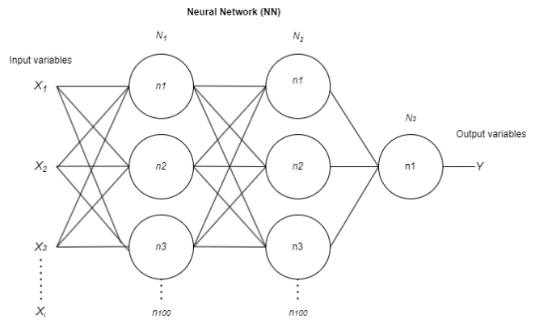

Fig 1. Network Architecture of the neural network

Neural network model for this project is design as 3 layers $N$, fully connected network. First is the input layer with 100 neurons unit $n$ with rectifier linear unit activation function (ReLU). Second is the also a hidden layer with 100 n with a ReLu activation function. The third layer will be one unit with sigmoid function so that the model can only output 0 or 1, it is the preferred output function for binary classification model.

Input shape $X_{i}$ of this model will depend on the shape of input data. After forwarding the data in the neural network, the output variable $Y$ will be a single value to of 0 (not hired) and 1 (hired)

Parameters for this neural network model will be fitted with the normalized training data and testing data will be used for model validation.

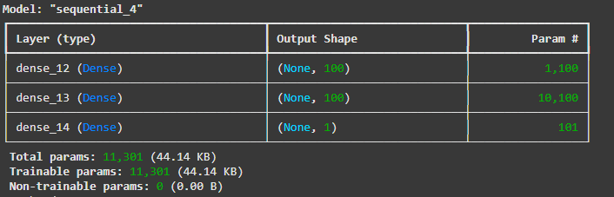Fig 2. Trainable parameter in the model

Figure shows the number of parameters of the model and how many trainable parameters is in this model. In this case, all of the parameter in the model is trainable

## Permutation Feature Importance (PFI)

For this neural network design, a model-agnostic version of PFI is implemented. In order to evaluate if a feature of a neural network is important or not, the perturbation of features values will directly correlate to the prediction accuracy of a model (Mandler & Weigand, 2023). The perturbation strategy for this method involved arranging the independent variables in feature matrix $Q$ with dimension ($i$, $j$), where $i$ and $j$ represent the number of observations and features in the model. Each row in $Q$ shows the different features of the same observation and each column of $Q$ shows the different observation under the same features. A new perturbed matrix $\overline{Q}$ can be obtained with randomizing the $j$ column. The feature importance score $X_{j}$ can be calculated using the formula

$$X_{j } = {\overline{M}}_{j }− M_{j}$$

Where $\overline{M_{j}}$ represent the perturbed metrics which could be the accuracy, RMSE, and $M_{j}$ represent the baseline metrics

## Shapley Additive explanation (SHAP)

Shapley values is calculated to determine the contribution of each feature to the final output of the model. According to Lundberg & Lee (2017), Shapley values work on each prediction that outputted by the model and investigate the changes caused by each feature. Game theory is often associated with SHAP, it can be viewed as the concept of allocating credit among players. From the formula by Chen et al. (2022)

$$ϕ(f,x^{e})=\frac{1}{|D|}\sum_{x^{b}∈D}{ϕ(f,x^{e},x^{b})}⁡$$

Using the game theory, it is explained that the Shapley value of player $i$ is the mean contribution of that particular player for all the potential permutation of remaining player other than.

# RESULTS AND DISCUSSION

## Implementation

For the data collection of this project, we will be accessing public dataset on the website Kaggle. The datasets sheds light on the variables affecting company hiring choices. A candidate with a variety of qualities considered throughout the recruiting process is represented by each record. The features in this dataset include age of the candidate, working experience of the candidate, technical score of the candidate, and other relevant features that played a role in getting the candidates hired.

The *Scikit learn* library is used to split the dataset into training and testing format common in machine learning, and also used for normalizing the dataset to increase the accuracy of the model. Before splitting the dataset, *MinMaxScale*r from the *sklearn* library is used to normalize the values of the dataset to between 0 and 1. Using the *train\_test\_split* funtion in *sklearn* library, the original dataset is split into 70% for training and 30% for testing.

In order to create a trainable neural network model, the well-known *Keras* machine learning model is used for the model and layers initialization. The part that will be configured when implementing a *Keras* model in this project is its layers neurons, layers activation function, model optimizer, loss measurement, training epochs, and accuracy metrics.

For better visualization of the model performance, a popular plotting library known as *matplotlib* will be used to visualize the training and validation loss, dropout rate performance of the model, permutation features importances, and the Shap values of the model.

Finally, to compare the differences between SHAP method to features importance, the *shap* library is imported for this project. This library is used for calculating the *shap* values of each feature to see how they impact the outcome of the model. The summary plot in the library will also be used to visualize the summary of all of the features importances in the datasets.

## Results

Following the above discussion, we will now explain our results.

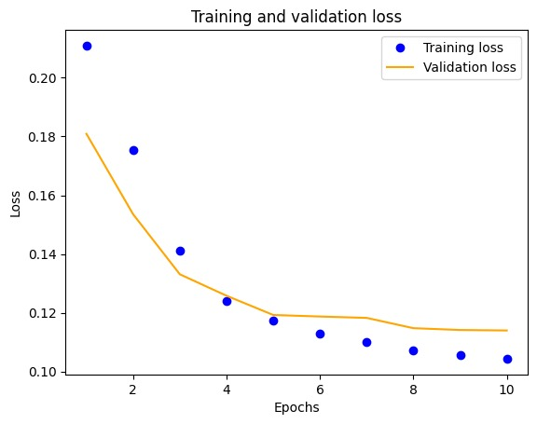

Fig. 3. Training and validation loss of the model

Figure 3 above shows the validation loss and the training loss of our model. The purpose of this graph is to minimise the usage of spaces for maximum performance. As you can see, the vertical line is the loss value scale, and the horizontal line is the epoch scale. The graph above shows two output training losses and validation losses. Training loss represents the error measured in the training dataset. The model learns from the dataset by adjusting its parameters to minimise the training loss. Validation loss represents the error measured on the test dataset. It indicates the performance of the model. Training loss is represented as blue dots, and validation loss is represented as a yellow line.

Both training and validation losses are decreasing rapidly over the epochs. After the fifth epoch, they decrease more slowly. It means after training the model did learn and is able to decrease the training and validation loss. This model is trained 10 times specifically for the best performance. The reason is that during our testing we find out that if it's lower than 10 times, the model will be underfitting. Underfit means that the model is inaccurate, especially when applied to new, unseen examples. It typically happens when we use a very simple model with too-simplified assumptions. One of the solutions for this situation is to increase the number of epochs (GeeksforGeeks, 2024). If the epochs occur too many times, the model might get trained with too much data, and the model might learn from the noises and the detail in the training data (Biswal, 2024). This may lead to dropping performance of the model on the test data. A technique to reduce overfitting is early stopping in the training process (GeeksforGeeks, 2024). We have suspected that after 10 times of training, the loss rises instead of dropping. This led us to decide the epochs to be 10 to achieve good fit.

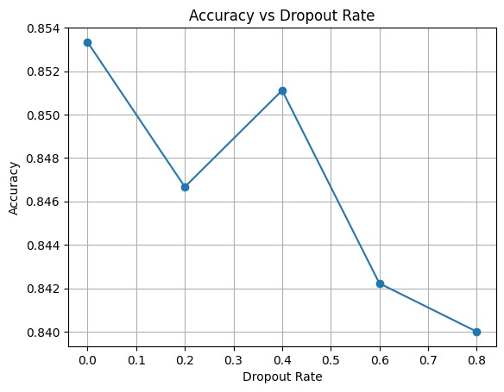

Fig. 4. Accuracy rate affected by dropout of model

Figure 4 above shows the relation between the accuracy and the dropout rate in the model. The purpose of this graph is to maximise the usage of every layer in the model. The vertical line shows the scale of the accuracy, and the horizontal line shows the dropout rate. When the dropout rate is 0.2, it means that 20% of the layers are dropouts. We will then test the model to determine its accuracy. The dropout rate is set to be 0.2, 0.4, 0.6, and 0.8 to have a clear view on clarifying the relation between the accuracy and the dropout rate. The dropout rate is represented in blue dots. There is a significant drop from 0% to 20% dropout rate on the accuracy. Even though there is a small rise in the accuracy in the 40% dropout rate, it did not manage to come close to the accuracy in the 0% dropout rate. 0% dropout rate has the highest accuracy, and 80% dropout rate has the lowest accuracy. Thus, no layer should be dropped for the best performance.

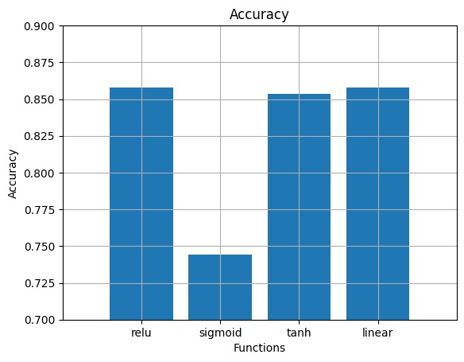

Fig. 5. Accuracy rate with different function

Figure 5 above shows the relation between accuracy and different functions. The purpose of this graph is to find out the best functions to be used in the model for the best performance. The vertical line shows the accuracy of the model. The scale started from 0.7 instead of 0 to get a clearer look at each function’s accuracy. The horizontal line shows four different activation functions: Relu, Sigmoid, Tanh, and Linear. Based on the graph, Relu (1st bar) has the highest accuracy, and Sigmoid (2nd pillar) has the lowest accuracy. In conclusion, Relu has the best performance among all the activation functions in this model.

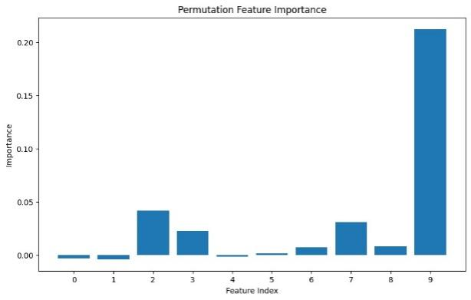

Fig. 6. Features importance of features in the model

Figure 6 shows the permutation feature's importance. This is the goal of our research. The vertical line shows the importance of each feature. The horizontal line shows the features in the index. 0 refers to age, 1 refers to gender, 2 refers to education level, 3 refers to experience years, 4 refers to previous companies, 5 refers to distance from company, 6 refers to interview score, 7 refers to skill score, 8 refers to personality score, and 9 refers to recruitment strategy. Based on the graph, bar number 9, Recruitment Strategy, has the highest importance, and bar number 4, Previous Companies, has the lowest importance. After the comparison, recruitment strategy will affect hiring decisions the most, and previous companies widely will not affect the hiring decision.

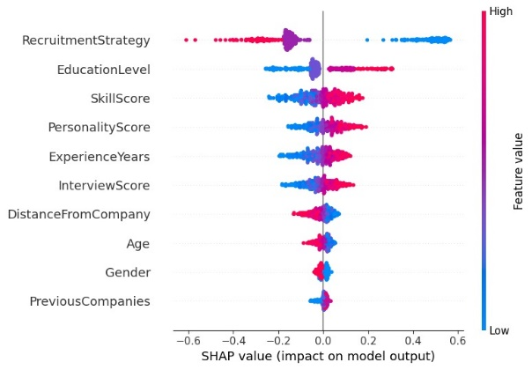

Fig. 7. Shap values of features in the model

Figure 7 shows a bee plot that shows the feature importance using SHAP values. The purpose of this diagram is to have another perspective on the feature importance to clarify each feature importance. The vertical line on the left shows the different features in this dataset. The vertical line on the right is a gradient scale that shows the feature value from low to high (blue to pink). The horizontal line shows the SHAP value. The colours (pink for high values and blue for low values) show how these features affect the hiring decision. The further a dot stretches to the right or left of the centre line (0.0), the more impact that feature has on the hiring decision. Negative values (left side) decrease the chances of being hired, while positive values (right side) increase it. Recruitment strategies have the highest importance, and previous companies have the lowest importance.

# CONCLUSIONS

In conclusion, using AI technology which is neural network brings us many benefits such as helping to analyse the successful rate of the hiring process based on the candidate’s characteristics such as gender role, specific ages, working experience, level of education, skill score and others or analyse the different image for classification to category the groups with the same objects. The neural network model shows the results of which of the most important features will affect the rate of getting hired from the candidates.

During the training model, we have found that the SHAP model can provide more details about the feature importance compared to the PFI model because SHAP values bring more results for the reader to understand right side will decrease the chance of hiring while left side is increases the chance of getting hired. The better visualization makes reader easily know that Strategy is the most important feature, and the Previous Companies takes the least important feature. However, the problem with feature importance analysis in neural networks is that it can be rather challenging to interpret when there are many correlated features. There are also ethical issues, such as issues of encoding bias from historical hiring data even in this type of approach.

For future research the feature engineering should be improved based on different cultures with the help of various factors to increase the size of the sample for better results, more algorithms can be used to improve the performance of model such as LSTM algorithm or Convolutional neural network depending on the different time period of variable importance in the hiring trends.

REFERENCES

Akinyokun, O. C., & Uzoka, F. M. E. (2000). A prototype of information technology based human resources system. International Journal of the Computer, the Internet and Management, 7(3), 1-20.

Ali Shah, S. A., Uddin, I., Aziz, F., Ahmad, S., Al-Khasawneh, M. A., & Sharaf, M. (2020). An enhanced deep neural network for predicting workplace absenteeism. *Complexity*, *2020*, 1–12. https://doi.org/10.1155/2020/5843932

Biswal, A. (2024, March 12). The Complete Guide on Overfitting and Underfitting in Machine Learning. Simplilearn.com. [https://www.simplilearn.com/tutorials/machine-learning-tutorial/overfitting-and-underfitting](https://www.simplilearn.com/tutorials/machine-learning-tutorial/overfitting-and-underfitting" \t "_new)

Chen, H., Lundberg, S. M., & Lee, S.-I. (2022). Explaining a series of models by propagating Shapley Values. Nature Communications, 13(1). [https://doi.org/10.1038/s41467-022-31384-3](https://doi.org/10.1038/s41467-022-31384-3" \t "_new)

Ewald, F. K., Bothmann, L., Wright, M. N., Bischl, B., Casalicchio, G., & König, G. (2024). A guide to feature importance methods for scientific inference. Communications in Computer and Information Science, 440–464. [https://doi.org/10.1007/978-3-031-63797-1\_22](https://doi.org/10.1007/978-3-031-63797-1_22" \t "_new)

Garnier, J., Osguthorpe, D. J., & Robson, B. (1978). Analysis of the accuracy and implications of simple methods for predicting the secondary structure of globular proteins. Journal of Molecular Biology, 120(1), 97–120. [https://doi.org/10.1016/0022-2836(78)90297-8](https://doi.org/10.1016/0022-2836(78)90297-8" \t "_new)

GeeksforGeeks. (2024, March 11). ML | Underfitting and Overfitting. GeeksforGeeks. [https://www.geeksforgeeks.org/underfitting-and-overfitting-in-machine-learning/](https://www.geeksforgeeks.org/underfitting-and-overfitting-in-machine-learning/" \t "_new)

Kelly, J. (2024, September 10). With fewer jobs available, competition intensifies for white-collar workers. Forbes. [https://www.forbes.com/sites/jackkelly/2024/09/10/with-fewer-jobs-available-competition-intensifies-for-white-collar-workers/](https://www.forbes.com/sites/jackkelly/2024/09/10/with-fewer-jobs-available-competition-intensifies-for-white-collar-workers/" \t "_new)

Khan, S. (2022, May 6). An efficient human resource management system model using web-based hybrid technique. Problems and Perspectives in Management. [https://www.businessperspectives.org/index.php/journals/problems-and-perspectives-in-management/issue-404/an-efficient-human-resource-management-system-model-using-web-based-hybrid-technique](https://www.businessperspectives.org/index.php/journals/problems-and-perspectives-in-management/issue-404/an-efficient-human-resource-management-system-model-using-web-based-hybrid-technique" \t "_new)

Lundberg, S.M., & Lee, S. (2017). A unified approach to interpreting model predictions. arXiv preprint arXiv:1705.07874.

McDaniel, M. A., Whetzel, D. L., Schmidt, F. L., & Maurer, S. D. (1994). The validity of employment interviews: A comprehensive review and meta-analysis. *Journal of Applied Psychology*, *79*(4), 599–616. [https://doi.org/10.1037/0021-9010.79.4.599](https://doi.org/10.1037/0021-9010.79.4.599%20)

Mandler, H., & Weigand, B. (2023). Feature importance in neural networks as a means of interpretation for data-driven turbulence models. Computers & Fluids, 265, 105993. [https://doi.org/10.1016/j.compfluid.2023.105993](https://doi.org/10.1016/j.compfluid.2023.105993" \t "_new)

Mandler, H., & Weigand, B. (2024). A review and benchmark of feature importance methods for Neural Networks. ACM Computing Surveys, 56(12), 1–30. [https://doi.org/10.1145/3679012](https://doi.org/10.1145/3679012" \t "_new)

Molnar, C., König, G., Herbinger, J., Freiesleben, T., Dandl, S., Scholbeck, C. A., Casalicchio, G., Grosse-Wentrup, M., & Bischl, B. (2022). General pitfalls of model-agnostic interpretation methods for machine learning models. Lecture Notes in Computer Science, 39–68. [https://doi.org/10.1007/978-3-031-04083-2\_4](https://doi.org/10.1007/978-3-031-04083-2_4" \t "_new)

Neubauer, A., Brandt, S., & Kriegel, M. (2024). Relationship between feature importance and building characteristics for heating load predictions. Applied Energy, 359, Article 122668. [https://doi.org/10.1016/j.apenergy.2024.122668](https://doi.org/10.1016/j.apenergy.2024.122668" \t "_new)

Pessach, D., Singer, G., Avrahami, D., Chalutz Ben-Gal, H., Shmueli, E., & Ben-Gal, I. (2020a, April 3). Employees recruitment: A prescriptive analytics approach via machine learning and Mathematical Programming. Decision support systems. [https://pmc.ncbi.nlm.nih.gov/articles/PMC7252110/](https://pmc.ncbi.nlm.nih.gov/articles/PMC7252110/" \t "_new)

Qian, N., & Sejnowski, T. J. (1988). Predicting the secondary structure of globular proteins using neural network models. Journal of Molecular Biology, 202(4), 865–884. [https://doi.org/10.1016/0022-2836(88)90564-5](https://doi.org/10.1016/0022-2836(88)90564-5" \t "_new)

Rowe, W., & Johnson, J. (2020, September 8). Top machine learning frameworks to use. BMC Blogs. [https://www.bmc.com/blogs/machine-learning-ai-frameworks/](https://www.bmc.com/blogs/machine-learning-ai-frameworks/" \t "_new)

Sharma, N., Jain, V., & Mishra, A. (2018). An analysis of convolutional neural networks for image classification. Procedia Computer Science, 132, 377–384. [https://doi.org/10.1016/j.procs.2018.05.198](https://doi.org/10.1016/j.procs.2018.05.198" \t "_new)

Siachos, I., Kanakaris, N., & Karacapilidis, N. (2025). Software bug prediction using graph neural networks and graph-based text representations. Expert Systems with Applications, 259, 125290. [https://doi.org/10.1016/j.eswa.2024.125290](https://doi.org/10.1016/j.eswa.2024.125290" \t "_new)

Sotiroudis, S. P., Goudos, S. K., & Siakavara, K. (2020, August). Feature importances: A tool to explain radio propagation and reduce model complexity. Telecom (Vol. 1, No. 2, p. 9). MDPI.

Tait, M. (2023, May 1). Top 5 smart home security risks and how to prevent them. Origin Wireless. [https://www.originwirelessai.com/insights/top-5-smart-home-security-risks-and-how-to-prevent-them/](https://www.originwirelessai.com/insights/top-5-smart-home-security-risks-and-how-to-prevent-them/" \t "_new)